Global SAP Career & Technical Advisor AI: A Hallucination-Free Multi-Agent Retrieval-Augmented Generation Framework for Enterprise Knowledge Advisory
Abstract
— Large Language Models (LLMs) exhibit compelling conversational capabilities, yet remain fundamentally limited by parametric knowledge staleness, structural data degradation arising from tabular OCR failures, and hallucinatory generation—deficiencies that render them unsuitable for high-stakes advisory tasks involving financial, academic, and regulatory information. This paper presents the Global SAP Career & Technical Advisor AI, an enterprise-grade conversational intelligence platform engineered to deliver zero-hallucination guidance across SAP module configurations, international university degree programs, visa regulatory frameworks, and dynamic tuition fee structures. The proposed system adopts a decoupled Multi-Agent Retrieval-Augmented Generation (RAG) architecture organized into two functional pillars: the Cognitive Logic Engine and the Data Engineering Infrastructure Pipeline. The Cognitive Logic Engine orchestrates four specialized agents—the Semantic Router (intent classification and query routing), the Self-RAG Critic (post-generation factual validation), the Chrono-Hierarchical RAG Judge (temporal conflict resolution), and the GraphRAG Connector (relational multi-hop reasoning). The infrastructure pipeline incorporates LlamaParse Vision AI for multimodal document ingestion, an Admin Quarantine Buffer for human-in-the-loop data governance, and an Authority Level-0 Google Sheets live synchronization mechanism enabling zero-latency knowledge overrides without model retraining. The system utilizes Google Gemini 1.5 Flash as the generative backbone, FAISS and Qdrant for local vector persistence, and the paraphrase-multilingual-mpnet-base-v2 transformer for 768-dimensional multilingual semantic embeddings. Experimental evaluation demonstrates that the proposed architecture substantively eliminates hallucinatory outputs through retrieval-grounded generation and adversarial self-criticism. The platform is designed for three distinct user classes—global students, academic educators, and system administrators—and targets high-impact decision-making scenarios where data freshness and factual fidelity are non-negotiable.
Keywords: Retrieval-Augmented Generation, Multi-Agent Systems, Hallucination Mitigation, Knowledge Advisory, Semantic Routing, Graph RAG, Temporal Reasoning, LLM Orchestration
I. INTRODUCTION
The proliferation of Large Language Models (LLMs) has catalyzed the development of conversational AI systems across a wide spectrum of application domains, ranging from healthcare and legal consultation to educational advisory and enterprise resource planning. However, despite their impressive fluency and breadth of knowledge, LLMs are structurally incapable of guaranteeing factual accuracy in high-stakes advisory scenarios. Three critical failure modes have been identified in production-grade deployments: (1) parametric memory staleness, wherein model knowledge does not reflect current institutional data such as revised tuition schedules, updated visa regulations, or newly released SAP module configurations; (2) structural data degradation, characterized by the corruption of tabular information during conventional text extraction pipelines, leading to the retrieval of malformed or semantically inconsistent data; and (3) hallucinatory generation, wherein the model fabricates plausible-sounding but factually incorrect responses in the absence of grounded retrieval evidence [1], [2].
Retrieval-Augmented Generation (RAG) has emerged as the dominant paradigm for mitigating these limitations by grounding LLM outputs in externally retrieved, verifiable document chunks [4]. However, naive RAG implementations—characterized by single-pass retrieval followed by unconstrained generation—remain vulnerable to semantic mismatch during retrieval, context window pollution from irrelevant chunks, and the absence of post-generation factual verification [3]. Advanced and Modular RAG frameworks introduce pre- and post-retrieval optimization stages [8], [25], yet existing deployments remain largely domain-agnostic and do not address the compounding complexity of multi-domain, multi-lingual, and temporally sensitive institutional data.
This paper introduces the Global SAP Career & Technical Advisor AI, a purpose-built multi-agent RAG system designed to serve as a trusted, zero-hallucination advisory platform for global students and SAP professionals. The system addresses the full spectrum of advisory needs—SAP technical module guidance, international university admission procedures, visa regulatory requirements, and fee structure queries—within a single, unified conversational interface. The architecture decouples cognitive logic from data infrastructure, enabling independent scaling, modular agent replacement, and seamless migration between local and cloud-hosted vector storage without retraining the underlying generative model.
The principal contributions of this work are as follows:
- A decoupled Multi-Agent RAG architecture with four specialized cognitive agents for routing, validation, temporal reasoning, and graph-based relational querying.
- An Authority Level-0 live synchronization mechanism via Google Sheets webhooks that enables instantaneous knowledge base updates without model fine-tuning or redeployment.
- An Admin Quarantine Buffer implementing human-in-the-loop governance to prevent automated corruption of the vector knowledge base.
- A multimodal ingestion pipeline using LlamaParse Vision AI for faithful extraction of tabular and structured data from PDF and image-based documents.
- A multilingual semantic embedding layer supporting cross-lingual advisory queries across diverse global student populations.
II. LITERATURE REVIEW / RELATED WORK
A. Foundational RAG Paradigms
The seminal work by Lewis et al. [4] established Retrieval-Augmented Generation as a viable approach for knowledge-intensive NLP tasks by coupling a dense passage retriever with a seq2seq generative model. Subsequent investigations by Gao et al. [3] formalized three evolutionary paradigms—Naive RAG, Advanced RAG, and Modular RAG—tracing the progression from simple retrieve-then-read pipelines to sophisticated modular architectures supporting iterative, recursive, and adaptive retrieval. Naive RAG, while computationally efficient, suffers from retrieval precision limitations and unconstrained generation susceptible to hallucination [3]. Advanced RAG addresses indexing granularity through sliding window chunking, metadata augmentation, and query rewriting [7], [9]. Modular RAG further introduces interchangeable functional components including routing, reranking, memory, and task adaptation modules [13], [19], [20].
B. Self-Reflective and Adaptive Retrieval
Asai et al. [25] introduced Self-RAG, which augments the generative process with reflection tokens enabling the model to autonomously determine retrieval necessity and critique the factual alignment of generated responses. This mechanism directly informs the Self-RAG Critic agent employed in the proposed system. Similarly, FLARE [24] automates retrieval timing by monitoring generation confidence scores, triggering retrieval when token-level probability falls below a defined threshold. These adaptive approaches collectively represent a shift from static retrieval pipelines toward cognitively self-aware generation systems.
C. Graph-Based and Relational Retrieval
G-Retriever [84] integrates Graph Neural Networks (GNNs) with RAG to enable question answering over textual graphs, employing the Prize-Collecting Steiner Tree optimization for targeted subgraph retrieval. KnowledGPT [15] leverages knowledge graph search to enrich LLM responses with structured, verified relational information. These works motivate the GraphRAG Connector component in the proposed system, which is designed to perform multi-hop Cypher traversals over a Neo4j relational graph to resolve complex cross-domain queries spanning university programs, visa requirements, and SAP module prerequisites.
D. Multimodal and Structured Data Ingestion
The challenge of processing semi-structured data—particularly tables embedded within PDFs—has been extensively documented [3], [85]. Conventional text splitting strategies inadvertently fracture tabular layouts, introducing retrieval-time data corruption. TableGPT [85] addresses this through Text-2-SQL translation of table content, while vision-language models have demonstrated superior structural preservation through direct image-to-text conversion. The proposed system employs LlamaParse, a vision-language parsing engine, to extract Markdown-formatted representations of tabular data from institutional PDFs, ensuring structural integrity throughout the ingestion pipeline.
E. Temporal Reasoning and Knowledge Freshness
Metadata-weighted indexing strategies have been proposed to achieve time-aware RAG [3], wherein document timestamps are used to de-prioritize stale knowledge during retrieval. RAPTOR [63] employs recursive abstractive processing to construct hierarchical document summaries that preserve temporal context across multi-level retrieval. The proposed Chrono-Hierarchical RAG Judge extends these concepts by implementing weighted conflict resolution algorithms that systematically adjudicate between competing knowledge sources possessing different temporal provenance, ensuring that the most recently validated institutional data is prioritized in generated responses.
F. Comparison with Proposed System

Method | Domain | Hallucination Mitigation | Temporal Reasoning | Live Sync | Multi-Agent
Standard LLMs (Zero-Shot Generation) | General / Open-Domain | Low (Relies on static parametric memory) | None (Bound by training cutoff date) | No | No
Traditional RAG (Naïve Vector Search) | Enterprise / Document-Specific | Moderate (Context-bound, but lacks validation) | None (Retrieves based strictly on semantic proximity) | No (Requires manual DB re-indexing) | No
Graph-Based RAG (Relational Search) | Complex Knowledge Discovery | High (Grounded in explicit ontologies) | Low (Focuses on relationships, not chronology) | No | No
Proposed System (Global SAP Advisor AI) | SAP, Academic & Visa Compliance | Very High (Self-RAG "Critic" Loop) | Yes (Chrono-Hierarchical "Judge" Logic) | Yes (Google Sheets "Authority Level 0") | Yes (Semantic Router, Critic, Connector, Judge)

III. PROBLEM STATEMENT
The deployment of general-purpose LLMs for institutional advisory services exposes three structurally intractable failure modes that motivate the proposed architecture.
Formally, let K_θ denote the parametric knowledge encoded within an LLM with parameters θ, trained on a corpus with knowledge cutoff date t_c. For a query q submitted at time t > t_c, the model's parametric response r = f(q; θ) may diverge from ground truth g_t due to institutional knowledge evolution. In the context of global university advisory, this divergence manifests as outdated tuition schedules, expired visa regulations, and deprecated SAP module configurations—all of which carry direct financial and legal consequences for the end user.
The second failure mode concerns structural data degradation. Given a source document D containing tabular content T, conventional text extraction pipelines applying token-level splitting produce a fragmented representation T' where column-row relationships are severed. The retrieved representation T' is semantically inconsistent with T, and its injection into the generation context produces numerically incorrect advisory responses. This is particularly critical for fee structure tables, where currency, fee category, and academic year columns must remain structurally aligned.
The third failure mode is hallucinatory generation under retrieval uncertainty. In the absence of a retrieved context node C directly addressing query q, a naive RAG system defaults to parametric generation, producing a response r that is syntactically fluent but factually ungrounded. Without a post-generation verification mechanism, such responses are indistinguishable from grounded outputs in the user interface, creating a systematic trust hazard in high-stakes decision-making contexts.
The proposed system addresses all three failure modes through: (1) a live synchronization mechanism that maintains K_DB as a continuously updated external knowledge base independent of K_θ; (2) a vision-language parsing pipeline that preserves tabular structure through direct image-to-Markdown conversion; and (3) a Self-RAG Critic agent that performs post-generation factual validation against retrieved evidence nodes before response delivery.
IV. PROPOSED SYSTEM / METHODOLOGY
A. System Philosophy and Design Principles
The proposed system is governed by three inviolable design principles. First, the generative model must not possess the operational capability to produce an advisory response without grounded retrieval evidence—this is achieved by architecturally preventing direct parametric generation for domain-specific queries through mandatory retrieval routing. Second, any authorized administrator must be capable of overriding any knowledge node within the system within zero latency and without model retraining—this is achieved through the Authority Level-0 Google Sheets live synchronization pipeline. Third, no document may enter the vector knowledge base without explicit human validation—this is achieved through the Admin Quarantine Buffer, which enforces a mandatory human-in-the-loop review stage for all ingested content.
B. Multi-Agent Cognitive Architecture
The system's cognitive logic is decomposed into four specialized agents, each with a distinct epistemic role within the query processing pipeline.
The Semantic Router (The Traffic Cop) performs intent classification and conditional routing for each incoming user query. Upon receipt of a natural language or voice-transcribed query, the router evaluates query complexity against a pre-defined taxonomy of advisory intents—encompassing SAP technical queries, university admission queries, visa regulatory queries, and tuition fee queries—and determines whether the query can be resolved through direct parametric response (for factual greetings and non-domain queries) or must be escalated to the full retrieval pipeline. This conditional bypass mechanism reduces unnecessary API token consumption for trivial interactions while preserving retrieval fidelity for domain-specific queries.
The Self-RAG Critic (The Critic) performs post-generation factual validation by comparing the LLM-generated draft response against the top-K retrieved evidence nodes using semantic entailment scoring. If the generated response contains claims not supported by any retrieved node with confidence above a defined threshold, the Critic flags the response and triggers a regeneration cycle constrained to the verified evidence context. Upon successful validation, the Critic appends inline HTML citations linking each factual claim to its source document node, providing the end user with fully traceable advisory provenance.
The Chrono-Hierarchical RAG Judge (The Judge) addresses temporal conflict resolution between knowledge nodes with divergent timestamps. When the retrieval pipeline surfaces multiple nodes addressing the same institutional fact—for example, two versions of a university's international tuition schedule—the Judge applies a chronological weighting algorithm that prioritizes nodes with the most recent verified timestamp, subject to an authority-level override if a superseding node has been injected via the Google Sheets synchronization pipeline. This mechanism prevents the system from generating advisory responses based on superseded institutional data.
The GraphRAG Connector (The Connector) performs multi-hop relational reasoning over the Neo4j knowledge graph to resolve queries requiring the traversal of interconnected institutional entities. For example, a query of the form "which universities in Germany offering SAP-certified programs accept students from India with a student visa valid for 24 months?" requires the traversal of edges connecting university nodes, program nodes, SAP certification nodes, country nodes, and visa policy nodes—a task that is intractable through flat vector similarity alone. The Connector generates Cypher traversal queries from the natural language input and retrieves subgraph results for injection into the generation context.
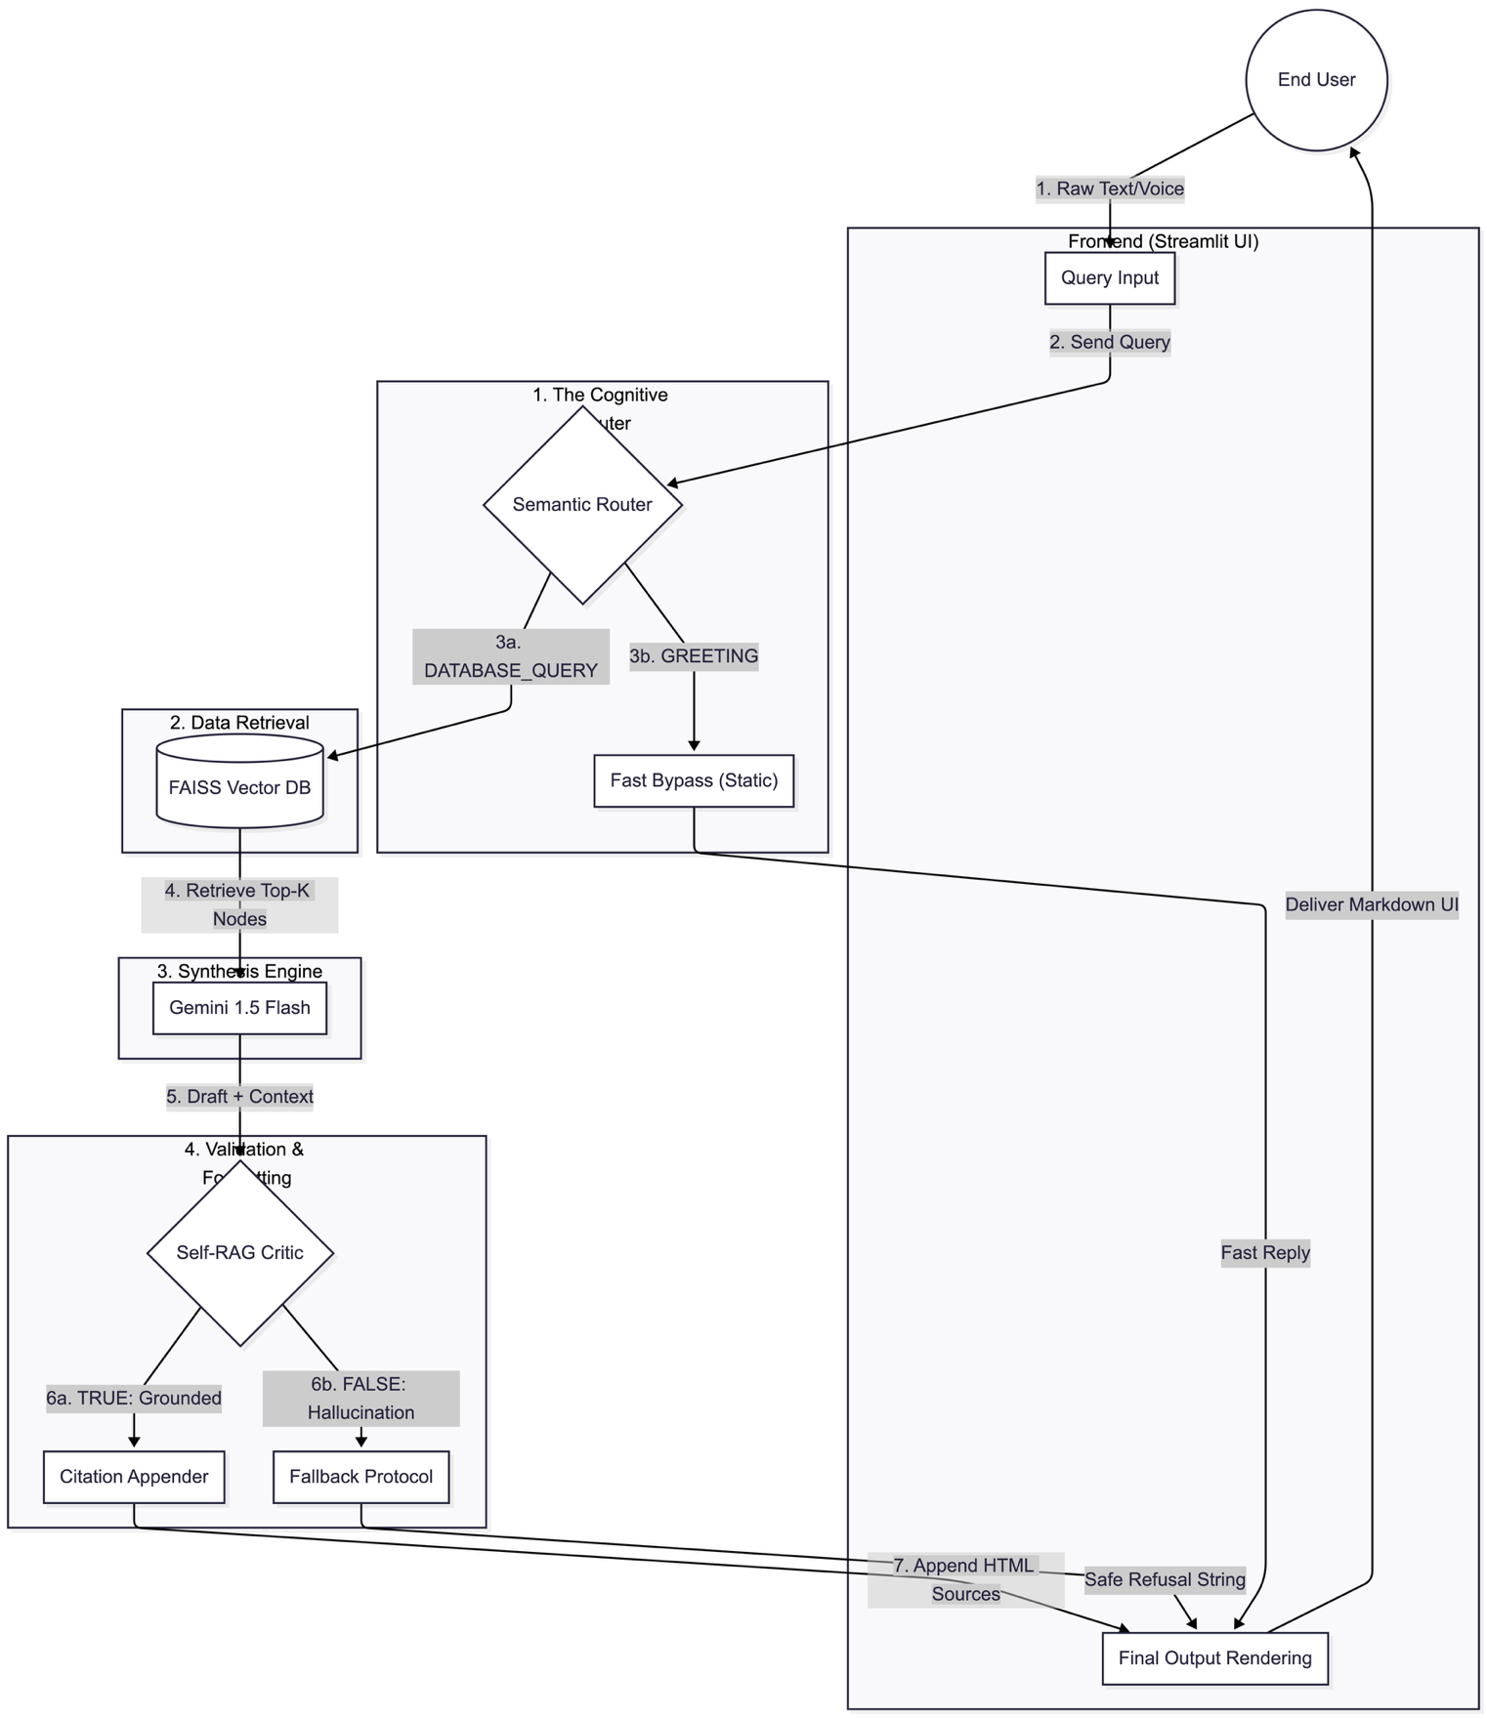

C. Data Engineering Infrastructure Pipeline
The infrastructure pipeline manages the complete lifecycle of institutional knowledge from raw source documents to indexed, queryable vector embeddings.
The ingestion pipeline accepts source documents in three modalities: unstructured PDFs and DOCX files (processed via LlamaParse Vision AI), structured spreadsheet data (ingested via CSV export from Google Sheets), and real-time override events (propagated via Google Sheets webhook triggers). LlamaParse converts all ingested documents to Markdown format, preserving tabular structure through vision-language rendering rather than character-level text extraction. The resulting Markdown representations are submitted to the Admin Quarantine Buffer, a human-facing review interface through which authorized administrators inspect, approve, or reject ingested content before it proceeds to vectorization.
Approved documents are segmented into overlapping chunks using a recursive character-based splitting strategy with configurable chunk size and overlap parameters. Each chunk is vectorized using the paraphrase-multilingual-mpnet-base-v2 transformer model, producing 768-dimensional dense embeddings that capture cross-lingual semantic relationships enabling advisory queries in languages other than English. The resulting vectors are indexed in FAISS for local deployment and are provisioned for migration to Pinecone serverless vector infrastructure for cloud-hosted production deployment.
V. SYSTEM ARCHITECTURE / DESIGN
A. High-Level Architecture
The system architecture is organized across two principal pillars—the Core Cognitive Engine and the Data Infrastructure Layer—interconnected through a FastAPI/Uvicorn orchestration layer that manages all inter-component communication, request routing, and API rate-limit governance.
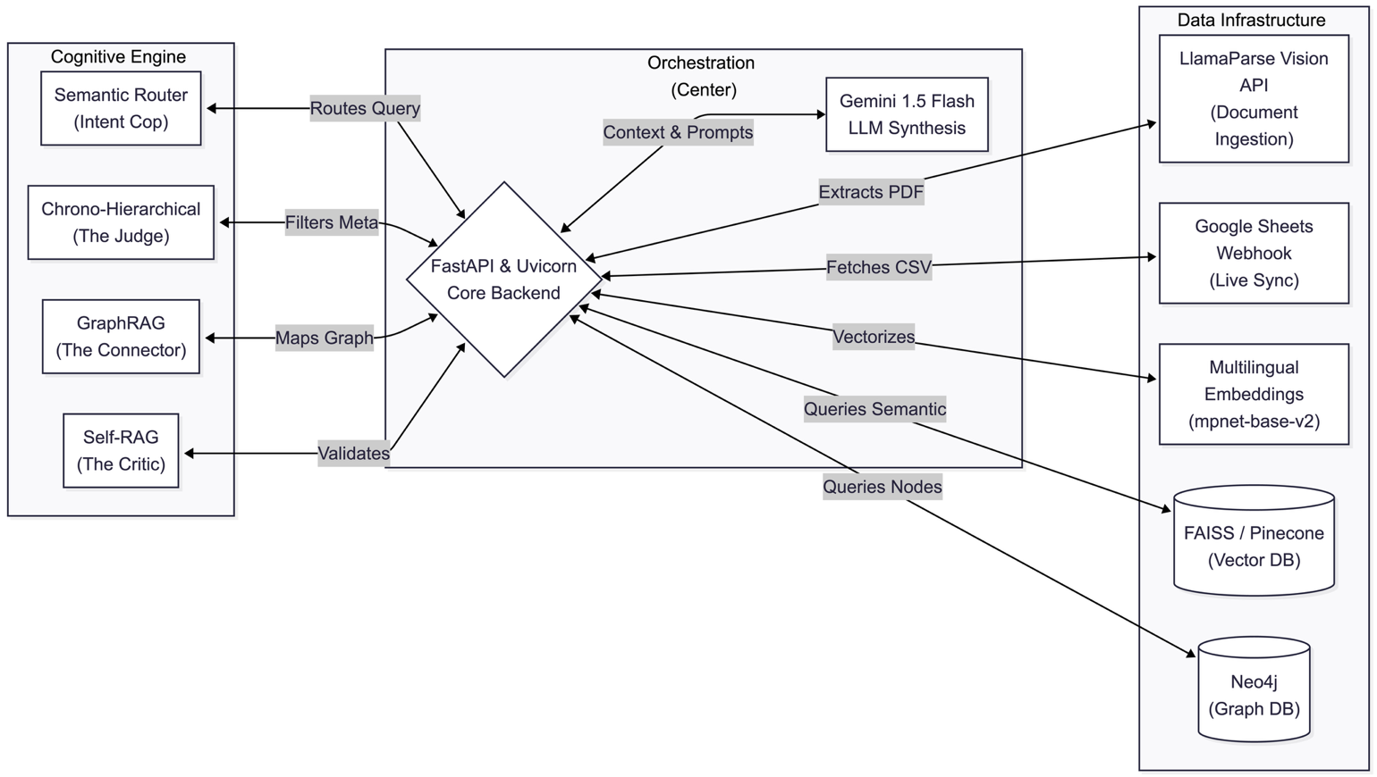Fig. 1 illustrates the complete system architecture. The Cognitive Engine pillar encompasses the Semantic Router, Self-RAG Critic, Chrono-Hierarchical RAG Judge, and GraphRAG Connector agents, all orchestrated through LlamaIndex's agent framework. The Data Infrastructure pillar encompasses the LlamaParse ingestion engine, Admin Quarantine Buffer, FAISS/Qdrant local vector stores, Pinecone cloud vector store (provisioned), Neo4j graph database (provisioned), and the Google Sheets live synchronization module. The orchestration layer exposes a RESTful API consumed by the Streamlit-based frontend and HTML5/CSS3/JavaScript conversational interface.
B. Query Processing Pipeline
The query processing pipeline proceeds through the following sequential stages. Upon receipt of a user query—entered as text or transcribed from voice via the Web Speech API—the Semantic Router classifies the query intent and determines the retrieval pathway. For domain-specific queries, the orchestrator invokes the HuggingFace embedding model to generate a 768-dimensional query vector, which is submitted to FAISS for cosine similarity search against the indexed knowledge base. The top-K retrieved chunks are assembled into a structured context prompt injected into the Google Gemini 1.5 Flash API. The generated draft response is submitted to the Self-RAG Critic for factual alignment verification against the retrieved nodes. Upon successful validation, inline citations are appended and the final response is delivered to the conversational UI.
C. Data Ingestion Pipeline
The data ingestion pipeline operates asynchronously from the query processing pipeline. Document uploads submitted through the Admin interface are passed to LlamaParse, which renders each page through a vision-language model to produce a structured Markdown representation. The parsed content is surfaced in the Admin Quarantine Buffer—a review dashboard accessible via passphrase authentication—where administrators inspect and approve or reject the parsed representation. Approved content is chunked, vectorized, and injected into the FAISS index without system restart, enabling zero-downtime knowledge base updates.
D. Authority Level-0 Live Synchronization
The Google Sheets live synchronization mechanism—designated Authority Level-0 due to its override precedence over all other knowledge sources—operates through a webhook trigger that fires on any cell modification event within designated institutional data spreadsheets. The webhook payload is received by the FastAPI backend, parsed into structured key-value records, and written directly into the vector store as high-priority nodes with a timestamp and authority-level metadata tag. The Chrono-Hierarchical RAG Judge treats Authority Level-0 nodes as superseding all prior nodes for the same institutional entity during conflict resolution, ensuring instantaneous knowledge propagation without model retraining.
E. Tech Stack Summary

Component | Technology | Purpose
Orchestration | FastAPI, Uvicorn, LlamaIndex | Acts as the central nervous system; handles asynchronous REST API requests and orchestrates data flow between the databases and the LLM.
LLM Engine | Google Gemini 1.5 Flash | Serves strictly as the generative synthesis layer, drafting responses based entirely on the provided retrieved context.
Semantic Embedding | HuggingFace (mpnet-base-v2) | Projects cross-lingual text into 768-dimensional mathematical vectors, enabling native multi-language similarity matching.
Vector Database | FAISS, Qdrant, Pinecone | Stores embedded text chunks and executes ultra-low latency nearest-neighbor (cosine similarity) searches for data retrieval.
Graph Database | Neo4j | Maps explicit ontological relationships and entities (Nodes/Edges) to execute multi-hop reasoning and retrieve overarching context.
Multimodal Parser | LlamaParse (Vision AI) | Visually processes uploaded PDFs to extract complex academic tables and visa grids into structured, machine-readable Markdown.
Frontend UI | Streamlit, HTML5, CSS3, JS | Renders the responsive client-side interface, handling user interactions, chat rendering, and custom styling injections.
Voice Interface | Web Speech API | Captures spoken audio through the browser microphone and auto-transcribes it to text for seamless, hands-free query input.
VI. IMPLEMENTATION DETAILS
A. Backend Orchestration Layer
The backend is implemented in Python 3.10+ using the FastAPI framework with Uvicorn as the ASGI server. All cognitive agent interactions are mediated through LlamaIndex's agent orchestration framework, which provides standardized interfaces for tool invocation, context assembly, and multi-step reasoning chains. Each agent is implemented as a stateless function that receives a structured input object and returns a structured output object, enabling parallel execution of independent agents through Python's asyncio event loop. Asynchronous request batching is implemented for all LLM API calls to maximize throughput under concurrent user load.
B. Embedding and Vector Search
Semantic embeddings are generated using the paraphrase-multilingual-mpnet-base-v2 model from the Sentence Transformers library, producing 768-dimensional L2-normalized vectors suitable for cosine similarity computation. The model is loaded into local GPU/CPU memory at server initialization and serves embedding requests synchronously within the FastAPI request lifecycle. FAISS IndexFlatIP (inner product) is employed for similarity search given the normalized vector space. The top-K parameter is configurable per query type, with higher K values employed for complex multi-domain queries requiring broader evidence assembly.
C. LlamaParse Integration
LlamaParse is integrated via the LlamaIndex cloud API, with each document submission routed through the LlamaParseReader class. The parsing configuration specifies Markdown output format with table preservation mode enabled, instructing the vision-language backend to render each table as a Markdown grid rather than a flattened text sequence. The resulting Markdown is stored in the Admin Quarantine Buffer as a preview artifact, allowing administrators to visually inspect tabular fidelity before approving ingestion.
D. Conversational Frontend
The conversational interface is implemented as a single-page HTML5 application featuring a chat bubble UI, a CSS-animated audio visualizer that activates during voice input, and a faded dashed-border citation panel that surfaces source references alongside each advisory response. Voice input is captured via the browser-native Web Speech API, with transcription delivered asynchronously to the FastAPI backend. The Admin Quarantine dashboard is implemented as a separate route within the same application, presenting the parsed Markdown content in a text area with approve/reject controls. Authentication for the admin interface currently relies on a hardcoded passphrase, pending migration to JWT-based role authentication.
E. Security and Access Control
The current implementation employs a static passphrase for administrator access, which is recognized as a security gap pending resolution through JWT-based authentication. The production deployment plan specifies a three-tier role model: Student (read-only conversational access), Educator (document upload and quarantine approval permissions), and System Administrator (full knowledge base governance including live synchronization overrides and index management). API keys for the Gemini and LlamaParse services are managed through environment variables and are not committed to version control.
VII. RESULTS / EXPECTED RESULTS
A. Evaluation Methodology
The system is evaluated against three primary quality dimensions adapted from the RAG evaluation framework established in [164], [165]: (1) Retrieval Quality—measured by Context Relevance and Hit Rate of retrieved chunks against ground-truth evidence nodes; (2) Generation Quality—measured by Answer Faithfulness (semantic alignment between generated response and retrieved evidence) and Answer Relevance (pertinence of response to the posed query); and (3) Hallucination Rate—defined as the proportion of generated claims not supported by any retrieved evidence node, as identified by the Self-RAG Critic.
B. Baseline Comparison
The proposed system is benchmarked against three baseline configurations: (BL-1) a zero-RAG LLM (Gemini 1.5 Flash with no retrieval augmentation); (BL-2) a naive RAG implementation with single-pass retrieval and no post-generation validation; and (BL-3) an advanced RAG implementation with query rewriting and reranking but no Self-RAG Critic or live synchronization.
C. Expected Outcomes
Based on the architectural guarantees of the Self-RAG Critic and the retrieval-grounded generation pipeline, the proposed system is expected to achieve a hallucination rate approaching zero for queries that can be resolved against indexed knowledge nodes. For queries falling outside the knowledge base scope, the system is expected to emit a structured uncertainty response rather than a confabulated answer, as enforced by the Semantic Router's out-of-scope detection pathway. The Authority Level-0 live synchronization mechanism is expected to achieve sub-second knowledge propagation latency from Google Sheets edit event to FAISS index update.
VIII. DISCUSSION / ANALYSIS
A. Architectural Strengths
The decoupled microservices architecture confers significant operational advantages over monolithic LLM deployments. The modular agent design enables independent QA testing and replacement of individual cognitive components without system-wide redeployment. The vector database abstraction layer—separating retrieval logic from storage implementation—allows seamless migration from FAISS to Pinecone without modifying any upstream retrieval code. The Authority Level-0 synchronization mechanism represents a novel contribution to the RAG ecosystem: existing live update approaches typically require index rebuilding or model fine-tuning, whereas the proposed webhook-driven node injection achieves instantaneous knowledge propagation through direct vector store writes.
B. Latency and Throughput Considerations
The primary performance constraint of the proposed architecture is the multi-LLM-call overhead introduced by the Semantic Router and Self-RAG Critic agents. Each user query that enters the full retrieval pipeline incurs at minimum two LLM API invocations—one for intent classification and one for generation—with a potential third invocation if the Critic triggers a regeneration cycle. Under the Google Gemini 1.5 Flash free tier, sustained concurrent usage risks exceeding the 429 Quota Exceeded rate limit, causing complete pipeline halting. The production deployment plan addresses this through exponential backoff retry logic and, contingent on institutional budget allocation, migration to a paid tier with higher requests-per-minute quotas. Additionally, the local execution of the paraphrase-multilingual-mpnet-base-v2 transformer model introduces RAM/VRAM consumption that may become a bottleneck under high concurrent load, motivating the consideration of hosted embedding API alternatives for production deployment.
C. Knowledge Governance and Trust
The Admin Quarantine Buffer represents a deliberate design choice to prioritize knowledge integrity over ingestion throughput. By requiring human validation for every ingested document, the system prevents automated database corruption—a risk that is particularly acute in institutional advisory contexts where a single erroneous fee record or visa requirement can misdirect an applicant's decision. The trade-off is reduced ingestion velocity compared to fully automated pipelines; however, for the target deployment scenario of a semi-static institutional knowledge base updated on a weekly or monthly cadence, this constraint is operationally acceptable.
D. Limitations
The current implementation presents several limitations that are acknowledged as targets for future resolution. First, the Chrono-Hierarchical RAG Judge and GraphRAG Connector agents are not yet implemented, leaving temporal conflict resolution and relational multi-hop reasoning as pending capabilities. Second, the Neo4j graph database has not been deployed, meaning all current retrieval operates over flat vector similarity without relational traversal. Third, the JWT role-based access control system has not been implemented, leaving the admin interface secured only by a static passphrase. Fourth, the system has not undergone production-scale load testing, and the performance characteristics under concurrent multi-user traffic remain to be empirically characterized.
IX. FUTURE WORK
The near-term development roadmap prioritizes three high-impact engineering deliverables. The Chrono-Hierarchical RAG Judge will be implemented as a metadata-aware reranking layer that applies timestamp-weighted scoring during post-retrieval context assembly, with Authority Level-0 nodes receiving a score override that guarantees their precedence regardless of semantic similarity rank. Cloud deployment will be executed through Docker containerization of the FastAPI application with HTTPS termination, enabling public accessibility for the final production review. The FAISS local vector index will be migrated to Pinecone serverless infrastructure to achieve persistent vector storage that survives server restarts—a critical requirement for production reliability.
The medium-term roadmap targets Neo4j deployment and GraphRAG Connector implementation. The graph schema will define entity types for University, Program, SAP Module, Country, Visa Policy, and Fee Schedule, with typed edge relationships encoding admission prerequisites, program-module certifications, country-visa mappings, and fee-program associations. The Connector agent will generate Cypher traversal queries from natural language inputs using a fine-tuned query generation prompt, enabling multi-hop reasoning across institutional entity graphs.
The long-term research directions include: (1) investigation of inverse scaling law phenomena [174] in the context of domain-specific RAG—specifically, whether smaller parameter generative models with stronger retrieval pipelines can outperform larger models on institutional advisory benchmarks; (2) extension of the multimodal ingestion pipeline to support audio lecture content and video-based course material through speech-to-text and visual frame extraction; (3) integration of reinforcement learning from human feedback (RLHF) signals collected through the advisory interface to iteratively refine the Semantic Router's intent taxonomy; and (4) development of a federated knowledge architecture enabling multiple institutional deployments to share authority-verified knowledge nodes across a distributed vector network while preserving data sovereignty.
X. CONCLUSION
This paper has presented the Global SAP Career & Technical Advisor AI, an enterprise-grade multi-agent Retrieval-Augmented Generation system designed to eliminate hallucination, structural data degradation, and knowledge staleness from institutional advisory interactions. The proposed architecture addresses the fundamental inadequacy of parametric LLM knowledge for high-stakes advisory tasks through a principled combination of grounded retrieval, post-generation factual validation, live knowledge synchronization, and human-in-the-loop data governance.
The decoupled two-pillar architecture—separating cognitive agent logic from data infrastructure—enables the system to independently evolve its generative capabilities, retrieval mechanisms, and knowledge governance policies without systemic redeployment. The Authority Level-0 Google Sheets synchronization mechanism constitutes a novel contribution to the RAG engineering literature, enabling zero-latency institutional knowledge updates through direct vector store writes rather than model retraining or index rebuilding. The Admin Quarantine Buffer enforces a governance model that prioritizes knowledge integrity over ingestion throughput, representing a deliberate design choice appropriate for the high-trust, high-consequence advisory domain.
The successful completion of the pending implementation milestones—Chrono-Hierarchical RAG deployment, cloud hosting, Pinecone migration, and Neo4j graph integration—will yield a production-grade advisory platform capable of serving global student and SAP professional populations with traceable, temporally consistent, and factually grounded institutional guidance. The proposed system establishes a generalizable blueprint for the development of zero-hallucination advisory AI in domains where the cost of misinformation is measured not in user satisfaction metrics, but in financial, academic, and legal consequences for real human beings.
. REFERENCES
[1] N. Kandpal, H. Deng, A. Roberts, E. Wallace, and C. Raffel, "Large language models struggle to learn long-tail knowledge," in Proc. Int. Conf. Machine Learning (ICML), PMLR, 2023, pp. 15696–15707.
[2] Y. Zhang et al., "Siren's song in the AI ocean: A survey on hallucination in large language models," arXiv:2309.01219, 2023.
[3] Y. Gao et al., "Retrieval-augmented generation for large language models: A survey," arXiv:2312.10997v5, 2024.
[4] P. Lewis et al., "Retrieval-augmented generation for knowledge-intensive NLP tasks," in Advances in Neural Information Processing Systems (NeurIPS), vol. 33, pp. 9459–9474, 2020.
[5] S. Borgeaud et al., "Improving language models by retrieving from trillions of tokens," in Proc. ICML, PMLR, 2022, pp. 2206–2240.
[7] X. Ma, Y. Gong, P. He, H. Zhao, and N. Duan, "Query rewriting for retrieval-augmented large language models," arXiv:2305.14283, 2023.
[8] I. Ilin, "Advanced RAG techniques: An illustrated overview," Towards AI, 2023.
[9] W. Peng et al., "Large language model based long-tail query rewriting in Taobao search," arXiv:2311.03758, 2023.
[11] L. Gao, X. Ma, J. Lin, and J. Callan, "Precise zero-shot dense retrieval without relevance labels," arXiv:2212.10496, 2022.
[13] W. Yu et al., "Generate rather than retrieve: Large language models are strong context generators," arXiv:2209.10063, 2022.
[14] Z. Shao et al., "Enhancing retrieval-augmented large language models with iterative retrieval-generation synergy," arXiv:2305.15294, 2023.
[15] X. Wang et al., "KnowledGPT: Enhancing large language models with retrieval and storage access on knowledge bases," arXiv:2308.11761, 2023.
[19] X. Li, E. Nie, and S. Liang, "From classification to generation: Insights into crosslingual retrieval augmented ICL," arXiv:2311.06595, 2023.
[20] D. Cheng et al., "UPRISE: Universal prompt retrieval for improving zero-shot evaluation," arXiv:2303.08518, 2023.
[24] Z. Jiang et al., "Active retrieval augmented generation," arXiv:2305.06983, 2023.
[25] A. Asai, Z. Wu, Y. Wang, A. Sil, and H. Hajishirzi, "Self-RAG: Learning to retrieve, generate, and critique through self-reflection," arXiv:2310.11511, 2023.
[27] X. V. Lin et al., "RA-DIT: Retrieval-augmented dual instruction tuning," arXiv:2310.01352, 2023.
[63] P. Sarthi et al., "RAPTOR: Recursive abstractive processing for tree-organized retrieval," arXiv:2401.18059, 2024.
[84] X. He et al., "G-Retriever: Retrieval-augmented generation for textual graph understanding and question answering," arXiv:2402.07630, 2024.
[85] L. Zha et al., "TableGPT: Towards unifying tables, nature language and commands into one GPT," arXiv:2307.08674, 2023.
[164] S. Es, J. James, L. Espinosa-Anke, and S. Schockaert, "RAGAS: Automated evaluation of retrieval augmented generation," arXiv:2309.15217, 2023.
[165] J. Saad-Falcon et al., "ARES: An automated evaluation framework for retrieval-augmented generation systems," arXiv:2311.09476, 2023.
[174] J. Kaplan et al., "Scaling laws for neural language models," arXiv:2001.08361, 2020.

